**4. Docker Basics**

1. List few benefits of docker

* Portability
* Isolation
* Resource Efficiency
* Rapid Deployment
* Version Control
* Scalability
* DevOps Integration
* Versioning and Rollbacks
* Ecosystem and Community
* Microservices Architecture

1. Install docker
2. Check docker version and copy the output

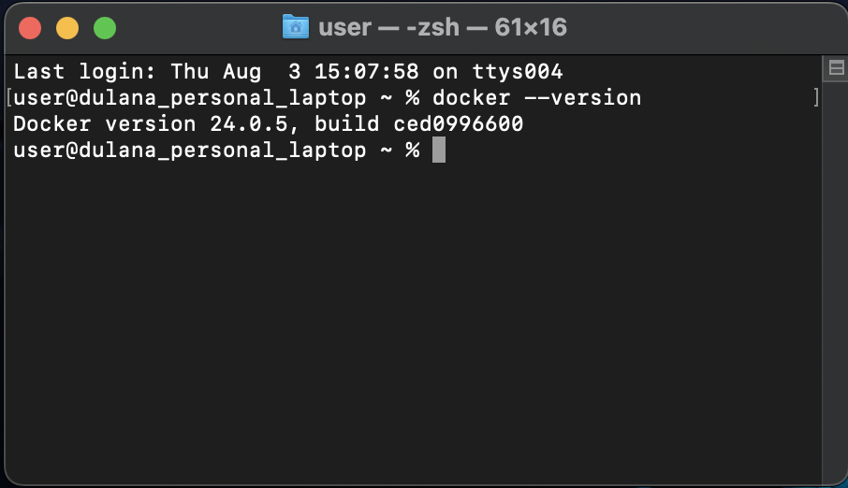

1. Create a new java project with maven
2. Create a main class and print “Hello docker example”
3. Create a jar file for the project (inside target directory)
4. Run the generated jar file inside target directory with command line
5. Display the output

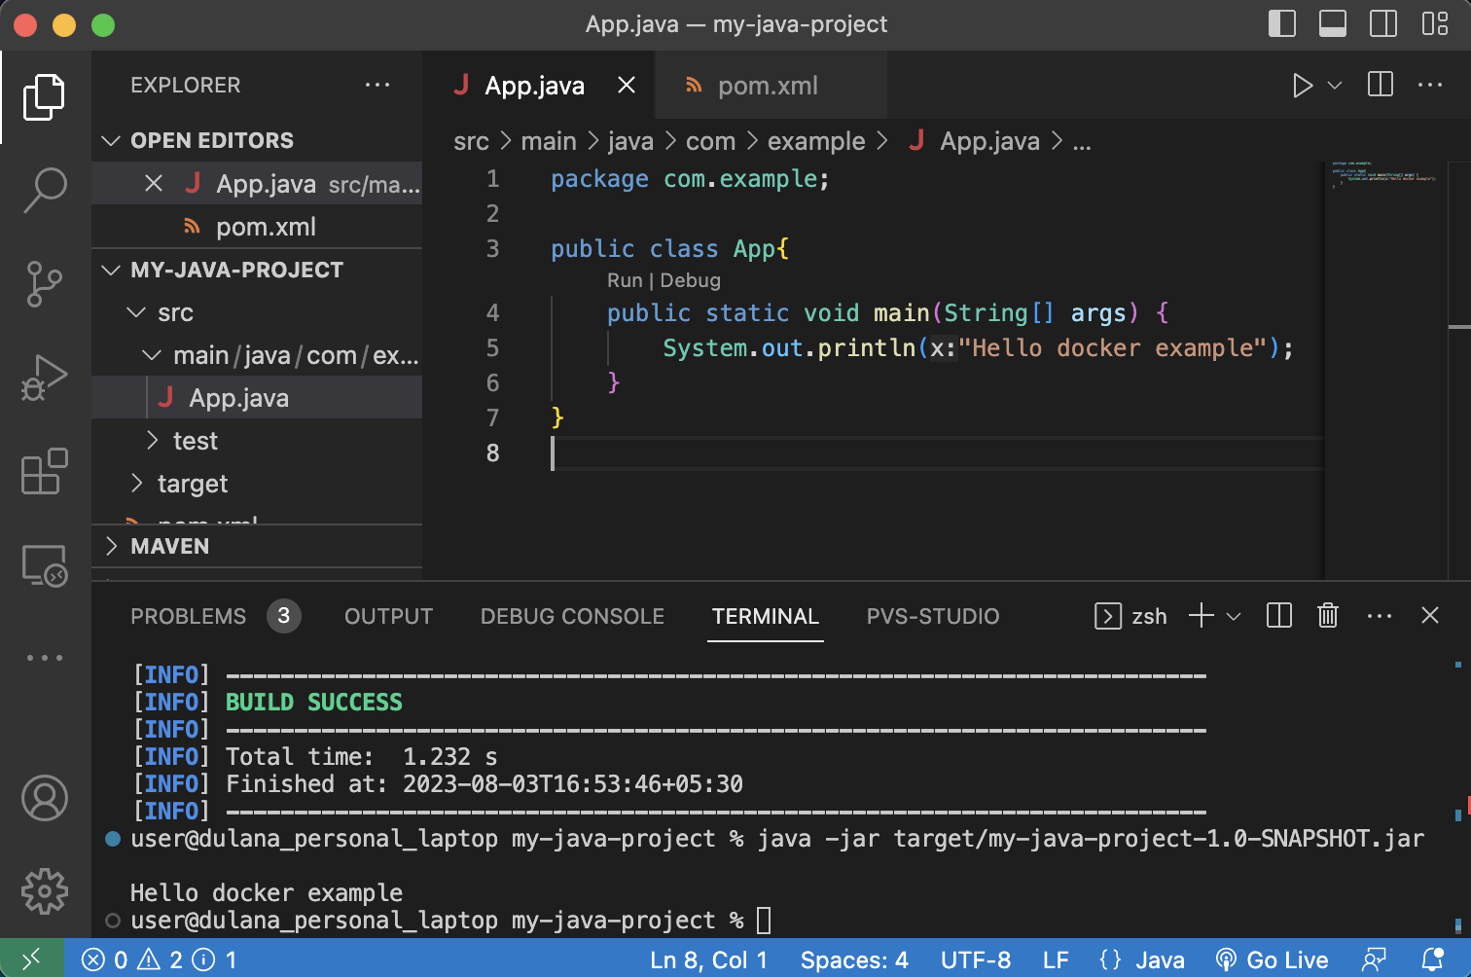

1. Create a docker image for the java project. What is the command you used?

**docker build -t my-java-project .**

1. List all the docker images and show output

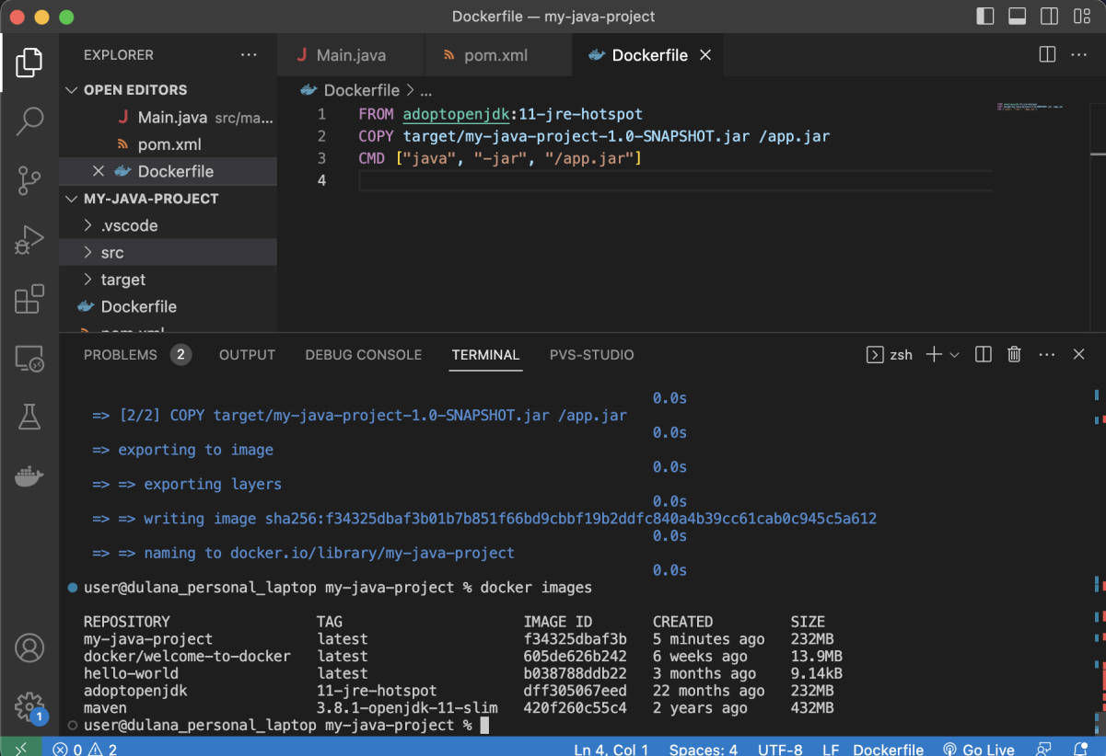

1. Run the created docker image. What is the command you used?

**docker run -d my-java-project**

1. List all the docker images and show output

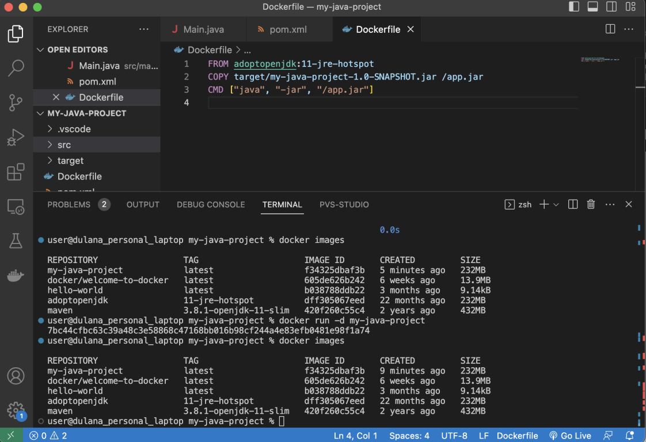

1. Stop the docker container?
2. List all the docker containers and show output

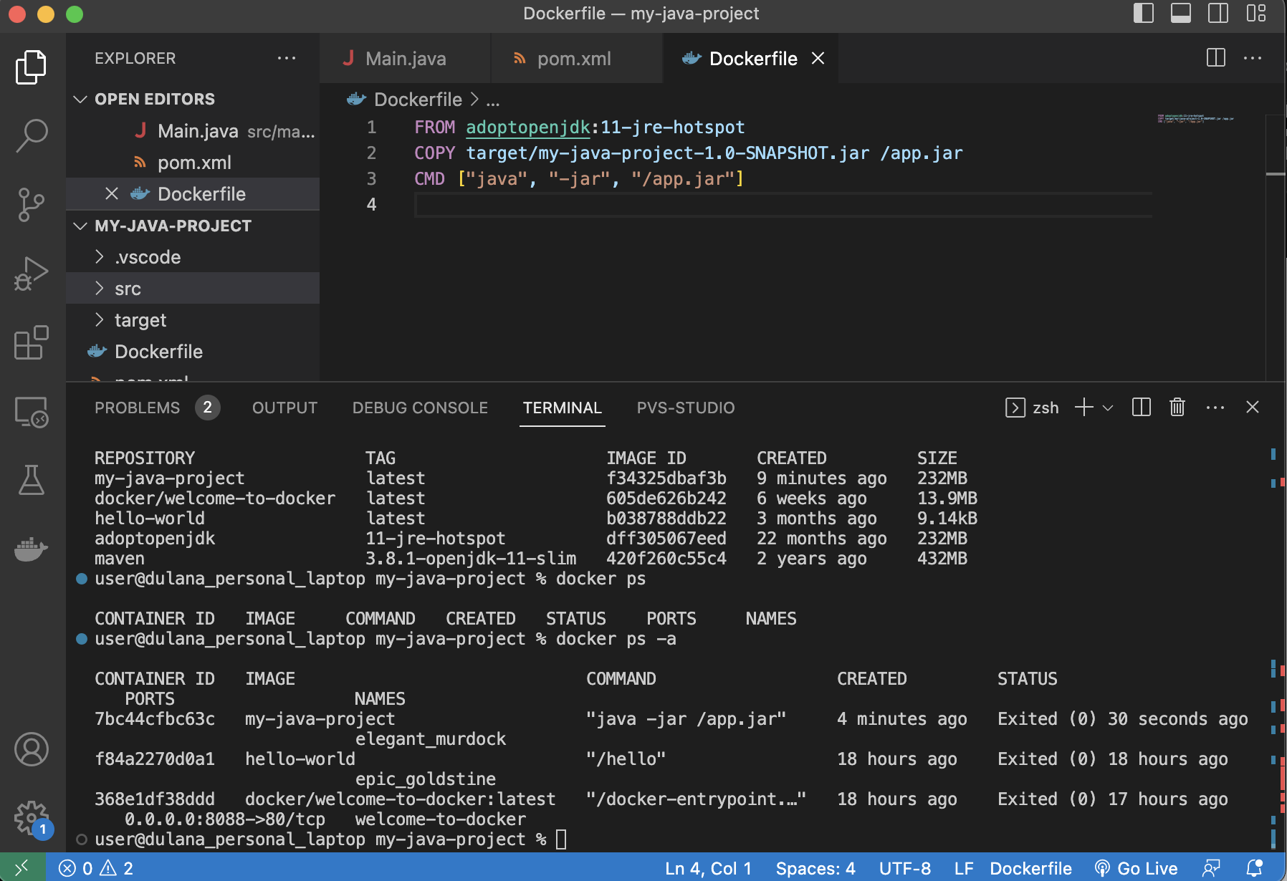

1. Remove the docker image. What is the command you used?

**docker rmi my-java-project**

1. List all the docker images and show output

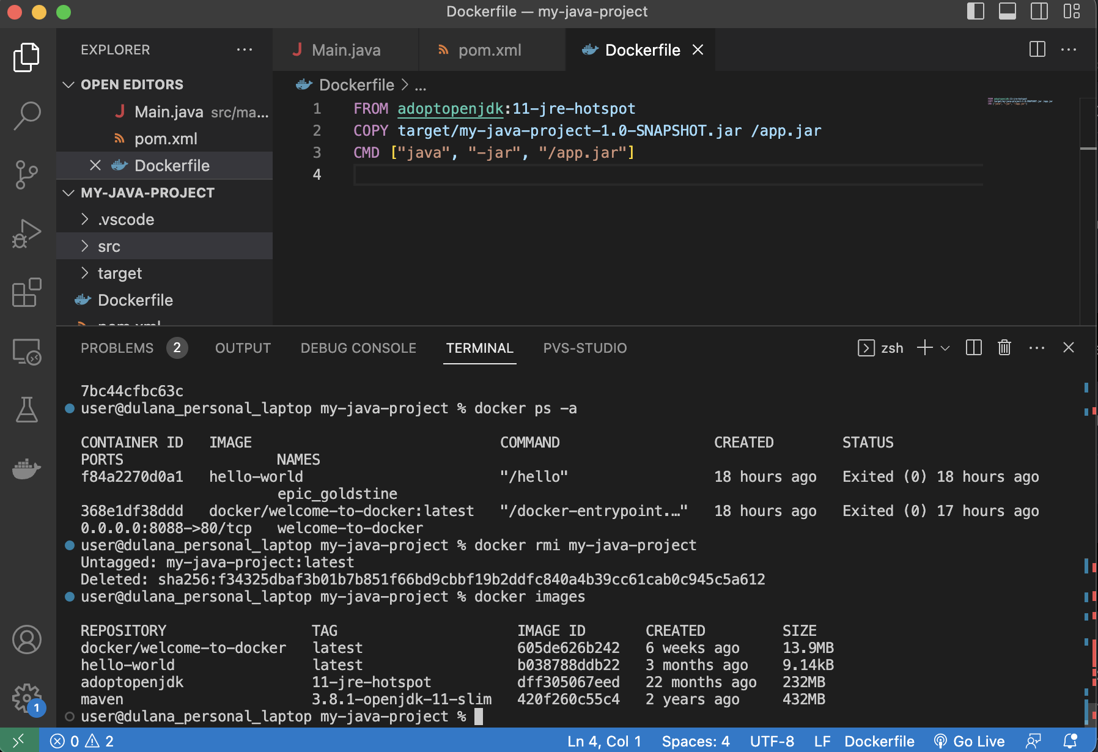

1. What is docker hub?

Docker Hub is a cloud-based service provided by Docker, Inc., designed to facilitate the management and distribution of container images. Docker Hub acts as a centralized repository where developers can store, share, and access Docker container images, streamlining the process of deploying applications using containerization technology. Container images encapsulate all the necessary components, including the application code, dependencies, libraries, and configurations required to run an application in an isolated and consistent manner. Docker Hub offers both public and private repositories, allowing developers to share their container images with the wider community or restrict access to authorized users or teams. Through Docker Hub, developers can easily collaborate, automate image builds, and maintain version control, enhancing the efficiency and scalability of their container-based applications.

1. Pull hello-world image from docker hub
2. Run hello-world image and show output

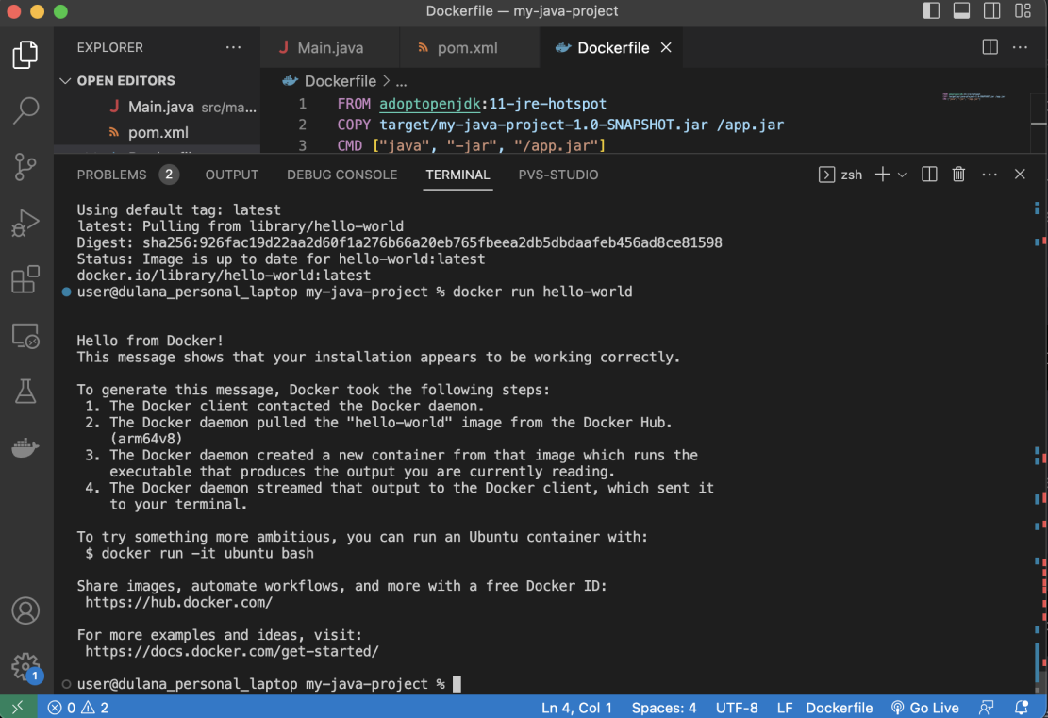

1. Pull and run mongodb as docker container
2. Open mongo shell
3. List mongodb databases

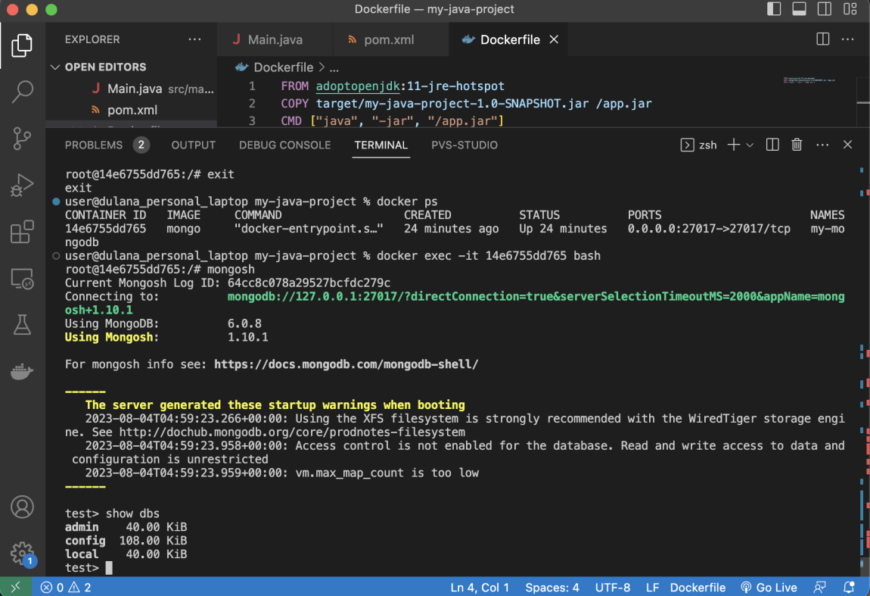

1. Add your codes and answer sheet to a directory named “docker-basic-training” and push it to your training github repository

